**Week 15 Assignment:**

**VERA MPENGULA**

**1. Data Dive:**

Working with the Netflix Shows dataset presented a few challenges during the data import and analysis process. One of the main difficulties was handling missing values, especially in columns crucial for analysis. This required careful consideration of data imputation techniques or exclusion of incomplete records to maintain data integrity. Additionally, ensuring consistency in data types and formats across columns was another aspect that required attention to avoid issues during querying and visualization tasks. One fascinating aspect observed in the dataset was the diversity of genres and categories represented in Netflix shows. From classic genres like drama and comedy to niche categories like stand-up comedy, reality TV, and documentaries, the dataset reflects the wide range of content available on the platform. This diversity not only showcases Netflix's extensive content library but also highlights the evolving preferences and interests of viewers worldwide

**2. Data Fun:**

There’s a total of one hundred shows/ movies and here is a list of the number of television shows/ movies released by the Netflix catalogue in each year:

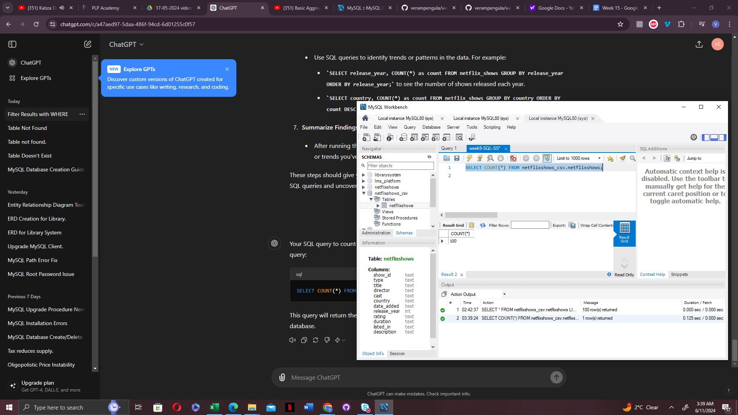

The script that gave me the output above:

**SELECT**

**COUNT(*) AS total_shows,**

**AVG(rating) AS average_rating,**

**AVG(duration) AS average_duration**

**FROM**

**Netflixshows_csv.netflixshows;**

**SELECT release_year, COUNT(*) AS release_count**

**FROM netflixshows_csv.netflixshows**

**GROUP BY release_year**

**ORDER BY release_year;**

**3. Ask Away:**

1. **How many tv programs fall under the different ratings?**

Based on the data below TV-MA was the most popular rating amongs the movies released in the Netflix catalogue followed by TV-14 and the least rate was

TV-G, which only had two programs under that genre.

The script that gave me the output above:

**SELECT rating, COUNT(*) AS rating_count**

**FROM netflixshows_csv.netflixshows**

**GROUP BY rating**

**ORDER BY rating_count DESC;**

1. How many movies and tv shows are there in the data set?

**SELECT**

**type,**

**COUNT(*) AS count**

**FROM**

**netflixshows_csv.netflixshows**

**GROUP BY**

**type;**

The output is screenshoted below.There was a total of 100 shows, which can be broken down into 55 movies and 45 tv shows

